 | Weekly Team Task Report | #12

Team: GeoLearn |  |  |  |  |  | Date: 4/14/2020
Project Title: Improving elementary education with custom online enironmental science lectures

 | Samuel Prassse  Present  On-time |  | Kaitlyn Grubb  Present  On-time |  | Tyler Pehringer  Present  On-time |  | 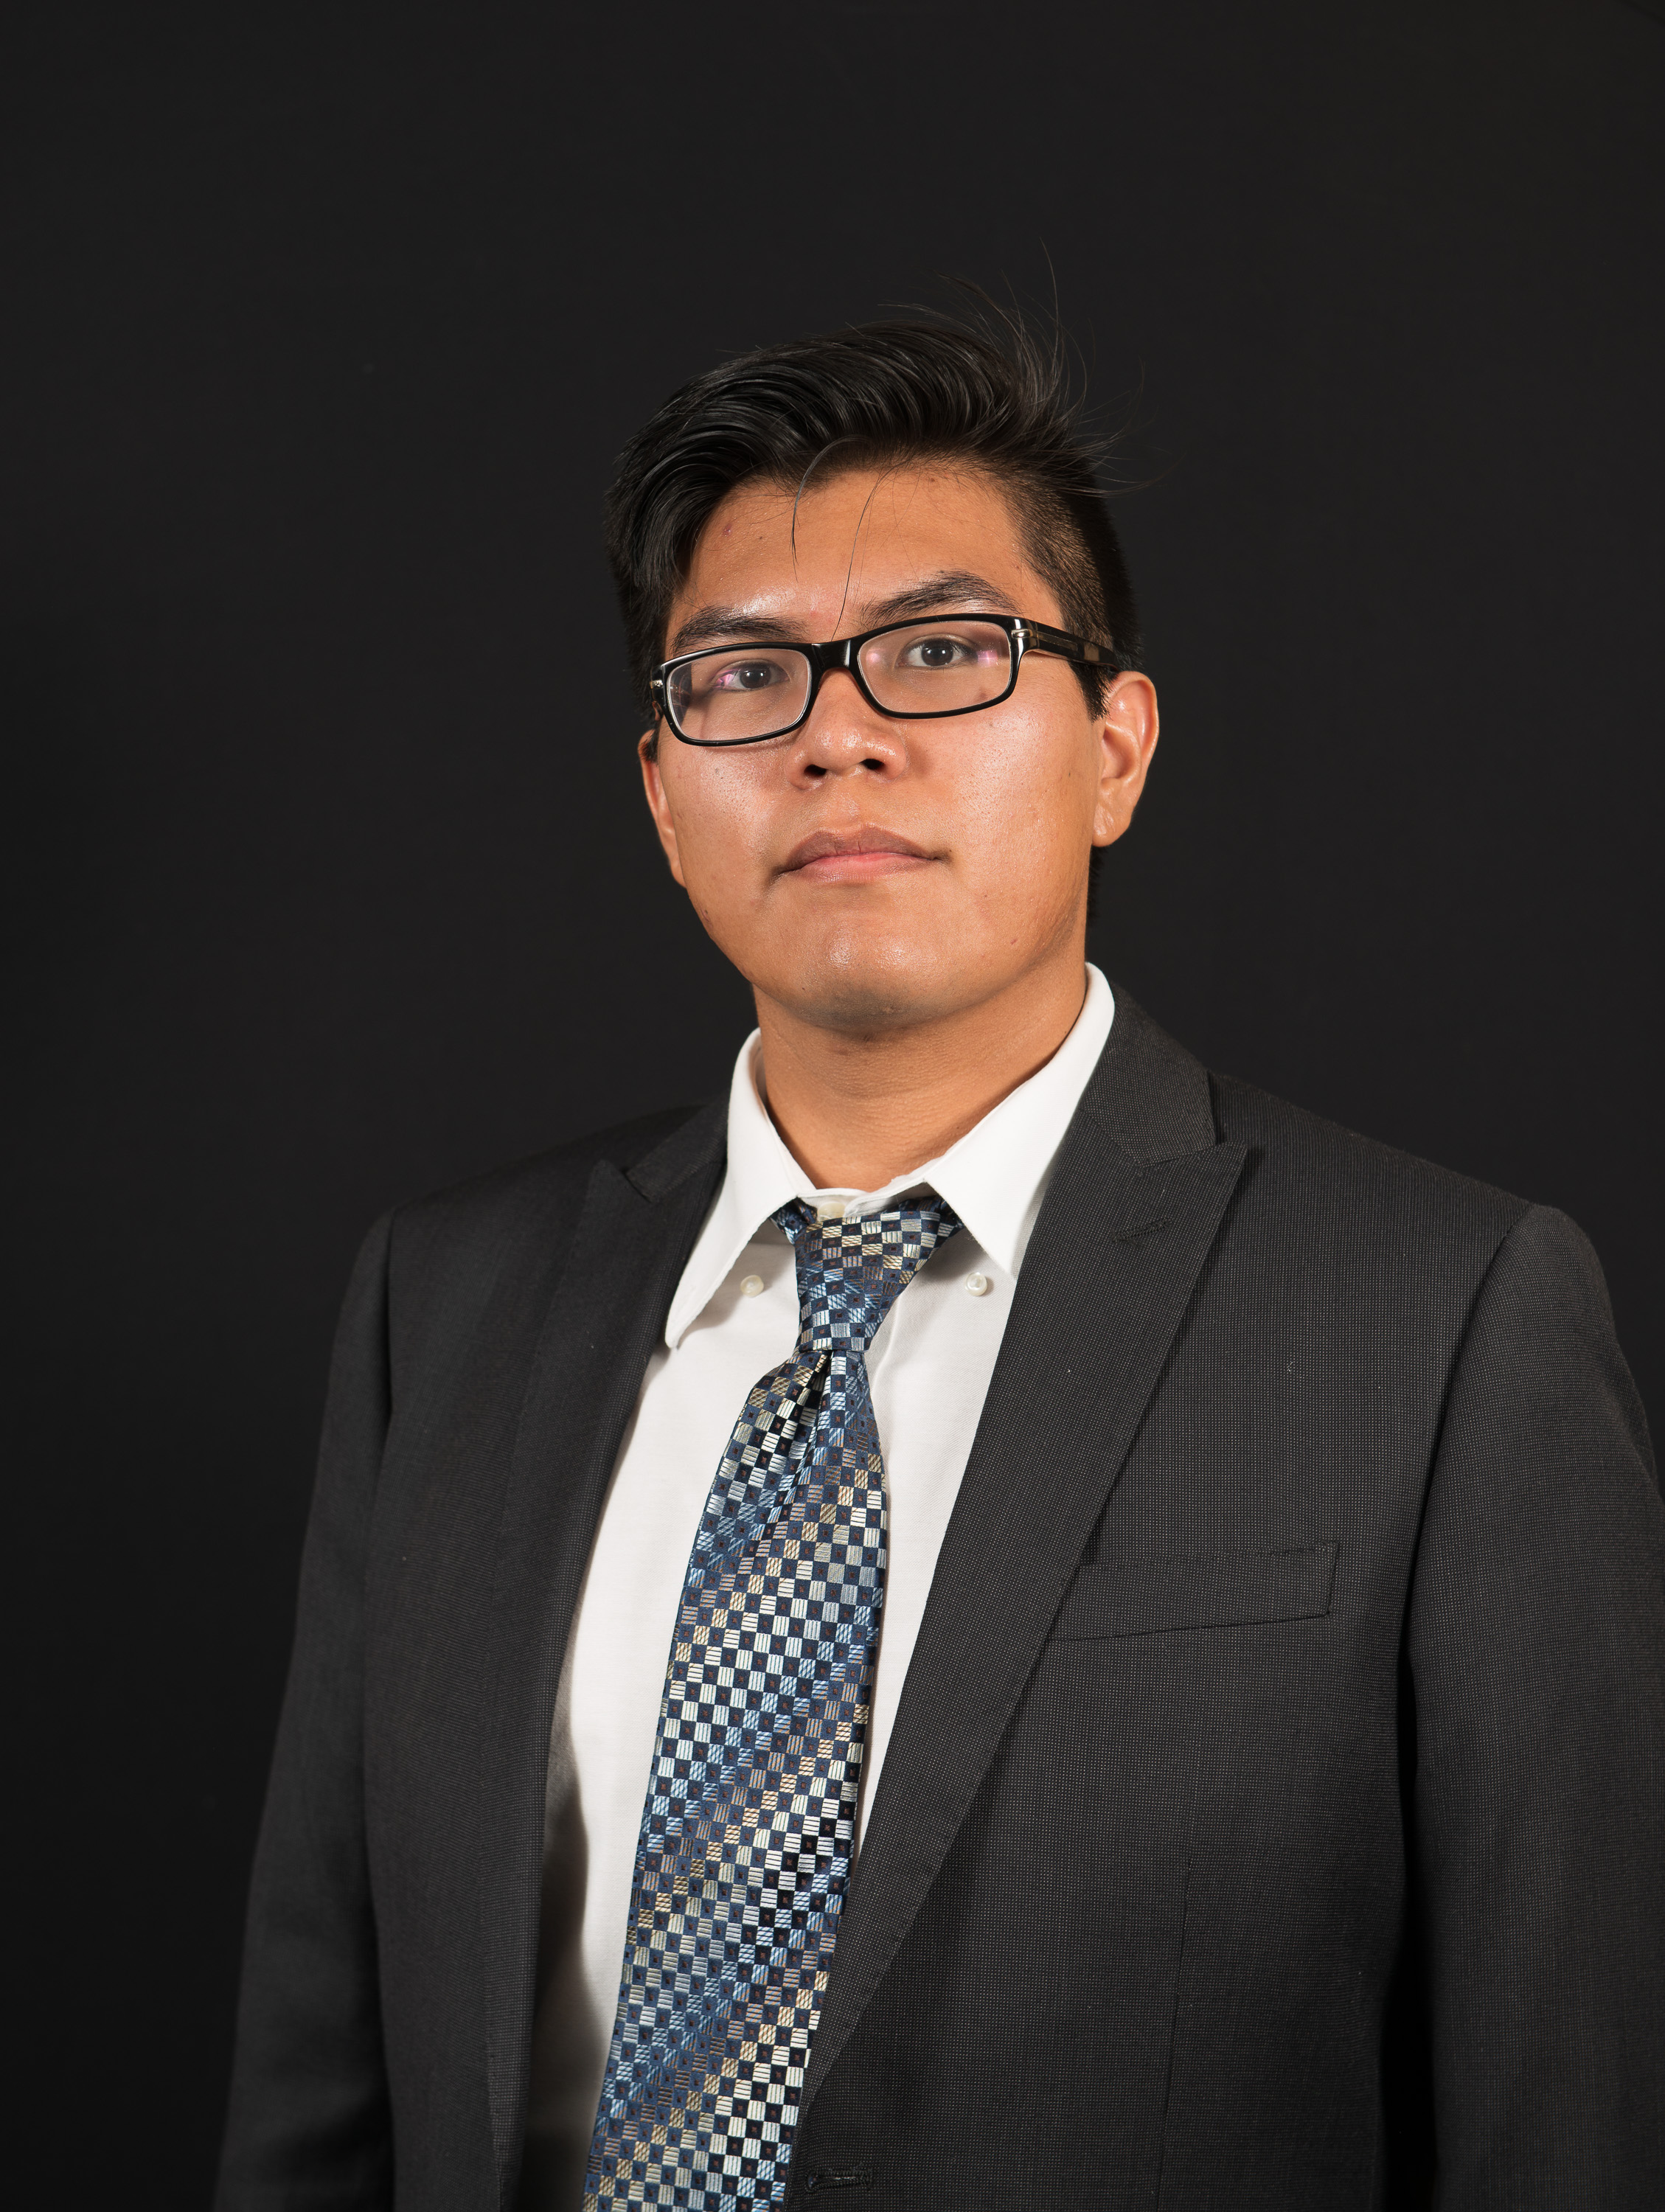 | Joshus Tenakhongva  Present  On-time

Recent Meetings:
- General Team Meeting
- Sponsor Meeting

TASKS COMPLETED since last meeting:
Task Title: Database differences | Task Initiation: 3/23 | Orig. Due Date: 3/27 | Status: In Progress
Who (%): Joshus (100%)
Description: Joshus is looking into the differences that he finds between the Animaps database, and our database.
Expected Outcome: Determine why their data is so different than the ones we currently have.

Task Title: Continue website design | Task Initiation: 3/9 | Orig. Due Date: None | Status: In Progress
Who (%): Tyler (100%)
Description: Tyler will continue to develop the design of the website through meetings with Dr. Doughty and Roo.
Expected Outcome: A sleek website that conforms to the sponsor’s specifications.

Task Title: Dry run presentation | Task Initiation: 4/6 | Orig. Due Date: 4/10 | Status: In Progress
Who (%): Team (100%)
Description: The team is preparing slides and scripts to record a video for the dry run version of the presentation that is due Friday.
Expected Outcome: A presentation covering the entire work year of capstone with the origina DR3 presentation mixed in.

Task Title: Grading Presentations | Who (%): Team (100%) | Rough Due Date: 4/13
Description: Over the weekend, all teams will review and “grade” *three* other team presentations. I will provide a grading sheet for you as a template, and I’ll specify which teams each team reviews. The team reviewed and sent off two presentations this weekend. We also received our feedback from the teams that reviewed us.

This week’s Tasks: Work plan for coming week
Task Title: Get website up and running | Task Initiation: 3/23 | Orig. Due Date: 4/10 | Status: In Progress
Who (%): Joshus (50%), Samuel (50%)
Description: Joshus and Samuel are working on getting the Django app up and running on an Apache server on the EC2 instance. There have been several issues with a few different processes that we are hoping to resolve in today’s meeting.
Expected Outcome: A fully functioning website prototype in beta build.

Upcoming Tasks: Planning
Task Title: Capstone Final Presentations | Who (%): Team (100%) | Rough Due Date: 4/23
Description: Capstone final presentations are due by end of business on Thursday April 23, the night before the regularly scheduled Capstone. The UGRADs folks promise there will be a way to upload them to the UGRAD site, which will be required. We will also upload them with BBlearn, for easy collection and access by team mentors for grading.

Task Title: Poster Due by COB | Who (%): Team (100%) | Rough Due Date: 4/19
Description: There is one more important change. As you know, every team has to prepare a poster and present that poster at Capstone. In the “virtual UGRADs” concept the organizers have come up with, UGRADs runs (virtually) for a *week* from 4/20-4/24…and they had wanted all posters and presentations by the 19th. We Capstone faculty pushed back saying you can’t deprive Capstone teams of a week, and got the 3/23 deadline through. But your POSTERS will be due by end of business on the 19th, so they can be part of the show and be viewed/judged in the poster competition. You will therefore want to be drafting your poster in the next few weeks as well, and reviewing it with your mentor. This is not a huge change from normal…just rules out last minute jobs on the poster.

Task Title: Capstone Final Presentations | Who (%): Team (100%) | Rough Due Date: 4/23
Description: Capstone final presentations are due by end of business on Thursday April 23, the night before the regularly scheduled Capstone. The UGRADs folks promise there will be a way to upload them to the UGRAD site, which will be required. We will also upload them with BBlearn, for easy collection and access by team mentors for grading.

Task Title: Develop complete website | Who (%): Tyler (100%) | Rough Due Date: 4/19
Description: Create a website on the CEFNS server to professionally document our project.

Task Title: Acceptance Demo | Who (%): Team (100%) | Rough Due Date: 4/24
Description: Work with your mentor develop a “Final
Demonstration Plan”, which is clearly driven by the functional and performance requirements that were developed for this project. This jointly-developed “demonstration plan” then becomes the agenda for an in-person demo with your project mentor, where you walk through and demonstrate all of the functionality promised

Task Title: Peer Eval #4 | Who (%): Team (100%) | Rough Due Date: 4/24
Description: Review and send off an Excel sheet containing the scores and description of our team ratings over the past few weeks. Due at capstone presentaiton time.

Task Title: Peer Eval #5 | Who (%): Team (100%) | Rough Due Date: 4/24
Description: Review and send off an Excel sheet containing the scores and description of our team ratings over the past few weeks. Due at end of semester.

Task Title: Final “As-Built” | Who (%): Team (100%) | Rough Due Date: 5/1
Description: The final report summarizes "the story" of the project into a single coherent narrative. If someone had time to read just one document to understand everything about this project, starting from
motivations and vision, summarizing the development process, and describing the resulting product,
this would be the document to read. Much of the material to be included in the report can and
should be shamelessly re-used from previous document products you've produced...with appropriate
condensing, seaming together and cleaning up, of course.

Other Problems / Other Issues:
- Server

Schedule:
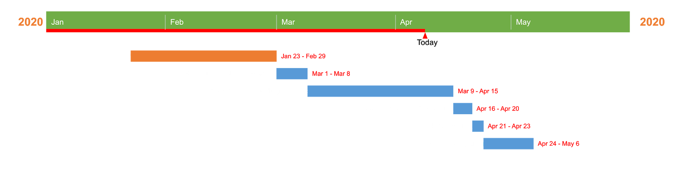

Github:
